INTELLIGENT LOGISTICS ROUTE PLANNER

Project Id: 11

Name : Archie Khunger (Team Leader)
Class Roll Number: 34
University Roll Number : 2028658
Section and Group: G(g1)

Name : Jahnvi
Class Roll Number: 9
University Roll Number : 2028436
Section and Group: G(g1)

Name : Antriksh Gehlot
Class Roll Number: 31
University Roll Number : 2028648
Section and Group: G(g1)

TABLE OF CONTENTS
- Problem Description 3
  - Dataset Description 3
  - Flow diagram 4
- Modules for Project Implementation…………………..…………………………5
  - Modules Used 5
  - Platform Used 6
- Machine Learning model/ Searching Technique used 7
- Evaluation metrics used 8
- Results and Visualizations 9
- Conclusion and Future Scope 11
- References 12

- Problem Description
The project focuses on developing a smart logistics optimization and prediction system using Machine Learning and Artificial Intelligence techniques. The system aims to predict delivery time based on factors like road distance, traffic level, and weather conditions, and also determine the most optimal delivery route using the A* (A-Star) searching algorithm.

The model automates delivery time prediction and route optimization, reducing manual planning effort and improving efficiency in logistics operations. By combining Machine Learning (Linear Regression) with graph-based pathfinding (A* algorithm), the system ensures both accurate prediction and optimal decision-making.

  - Dataset Description
The dataset used in this project is manually created and consists of logistics-related attributes between different locations.
Features used:
1.From: Starting location
2.To: Destination location
3.Road_Distance_km: Distance between locations 4.Avg_Speed_kmph: Average speed of travel 5.Delivery_Time_min: Actual delivery time 6.Traffic_Level: Traffic condition (Low, Medium, High) 7.Weather_Impact: Weather effect on delivery 8.Euclidean_Distance: Straight-line distance (used as heuristic)
The dataset is used for:
1.Training the Machine Learning model
2.Building the graph for route optimization

1.2 Flow Diagram

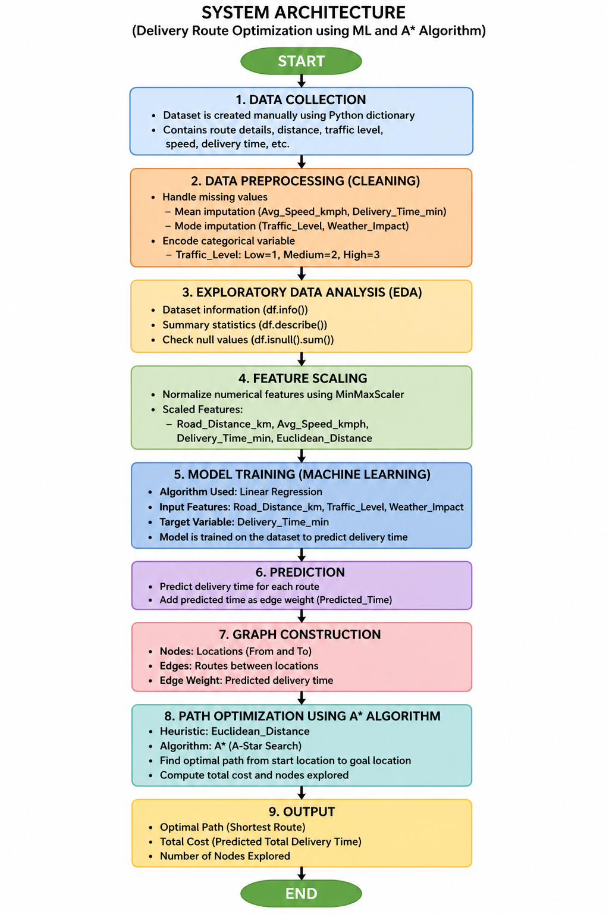 2. Modules for Project Implementation

2.1 Modules Used

1.Pandas – Used for data manipulation and analysis
• pd.DataFrame() – to create dataset
• fillna() – to handle missing values
• map() – to encode categorical data

2.NumPy – Used for numerical operations

3.Scikit-learn
• MinMaxScaler – for feature scaling
• LinearRegression – for ML model training and prediction

4.Heapq – Used for implementing priority queue in A* algorithm

5.NetworkX – Used to create and visualize graph

6.Matplotlib – Used for plotting graphs and visualizations

2.2 Platform Used
1. Visual Studio Code
Used for writing, debugging, and executing the code efficiently with extensions.
2. Jupyter Notebook
Used for step-by-step execution, visualization, and better understanding of each phase of the project

3. Machine Learning Model/ Searching Technique Used(Describe each ML model/ searching technique used)

Linear Regression (Machine Learning Model)
Linear Regression is used to predict delivery time based on input features:
- Road Distance
- Traffic Level
- Weather Impact
It finds the relationship between dependent and independent variables and predicts continuous values.
A Algorithm (Searching Technique)*
A* is an informed search algorithm used to find the shortest path.
Working:
- Uses cost function:
f(n) = g(n) + h(n)
where:
g(n) = actual cost
h(n) = heuristic (Euclidean distance)
- Ensures optimal and efficient route selection
Used here to:
- Find best route from Warehouse → Pacific Mall
4. Evaluation Metrics Used
1. Prediction Accuracy (Visual Comparison)
Comparison between:
- Actual Delivery Time
- Predicted Delivery Time
2. Cost Function (A Algorithm)*
- Total cost of path (sum of predicted delivery times)
3. Nodes Explored
- Number of nodes visited during A* search
- Measures efficiency of algorithm

5. Results and Visualizations
a.Graph visualization of logistics network using NetworkX
b.Optimal path found using A* Algorithm
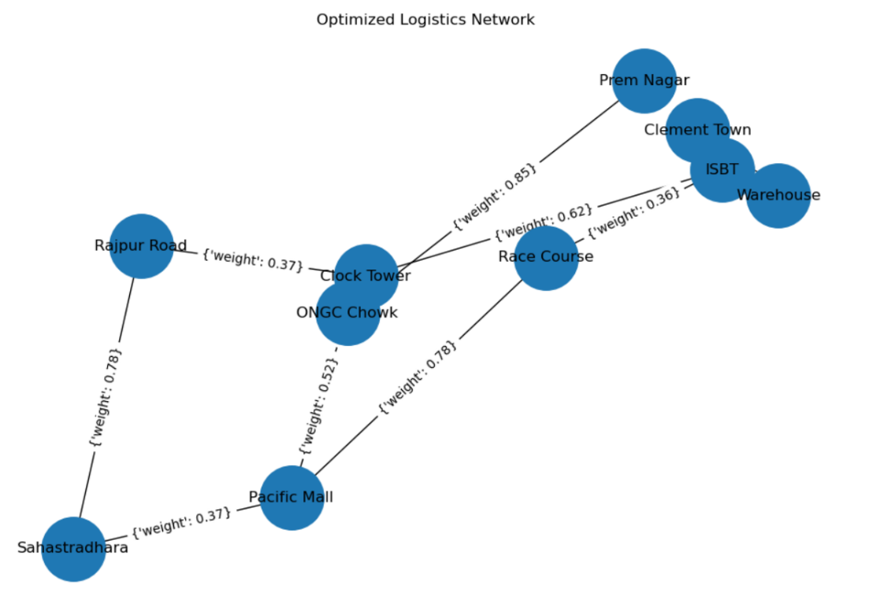
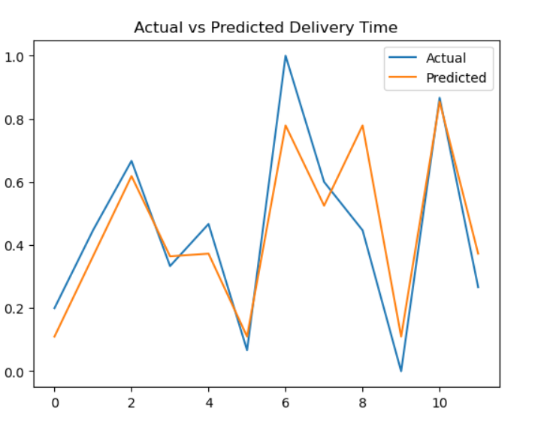

6. Conclusion and Future Scope:
Conclusion:
The project successfully integrates Machine Learning and Artificial Intelligence to:
- Predict delivery time accurately
- Find optimal routes efficiently
The system improves logistics planning and reduces delivery delays.
Future Scope:
- Use larger real-world datasets
- Apply advanced models like Random Forest or Neural Networks
- Integrate real-time traffic APIs
- Build a web or mobile application for live tracking

7. References:
Books:
- Let Us Python – Yashavant Kanetkar
Online Resources:
- GeeksforGeeks – https://www.geeksforgeeks.org/
- TutorialsPoint – https://www.tutorialspoint.com/
- Stack Overflow – https://stackoverflow.com

